Chapter 6, Solution 28.

We may treat this like a resistive circuit and apply delta-wye transformation, except that R is replaced by 1/C.

20 μF
C_{c}
C_{b}
C_{a}
50 μF

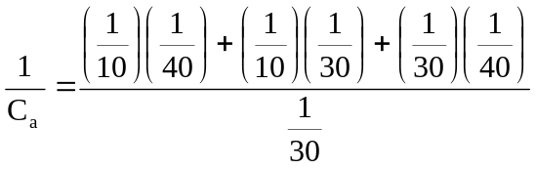
= 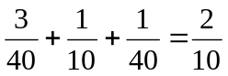

C_{a} = 5μF

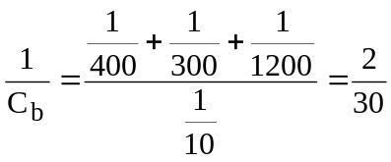
C_{b} = 15μF

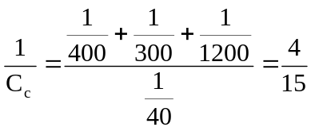
C_{c} = 3.75μF

C_{b} in parallel with 50μF = 50 + 15 = 65μF
C_{c} in series with 20μF = 23.75μF
65μF in series with 23.75μF = 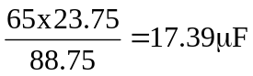
17.39μF in parallel with C_{a} = 17.39 + 5 = 22.39μF

Hence C_{eq} = 22.39μF

